Name: Jaswanth babu R R
Reg no: 192512341
Course code: advanced wireless communication system
Course code: ECE5610

Experiment: 6
MATLAB – Simulation and BER Analysis of MIMO and Beamforming

Aim:
To simulate SISO and MIMO wireless links and analyze BER, SNR, received signal strength and beam steering behavior using MATLAB.

Objectives:
- To simulate a basic SISO and MIMO wireless link.
- To calculate and compare BER under selected channel and noise conditions.
- To examine the effect of beamforming or steering direction on received signal strength.
- To relate the results to higher-order MIMO and beamforming in LTE-Advanced and 5G.

Software Required:
- MATLAB

Objective – 1: Simulate SISO and MIMO Wireless Links:

MATLAB Program:

clc; clear; close all;
SNR_dB = 0:2:20;
BER_SISO = zeros(size(SNR_dB));
BER_MIMO = zeros(size(SNR_dB));
for k = 1:length(SNR_dB)
N = 10000;
bits = randi([0 1],N,1);
tx = 2*bits-1;
snrLin = 10^(SNR_dB(k)/10);
noise = randn(N,1)/sqrt(2*snrLin);
rx = tx + noise;
bits_hat = real(rx)>0;
BER_SISO(k) = mean(bits_hat~=bits);
% Simple 2x2 MIMO equivalent link
H = (randn(2,2)+1j*randn(2,2))/sqrt(2);
h_eff = sqrt(sum(abs(H(:)).^2)/2);
noise2 = randn(N,1)/sqrt(2*snrLin);
rx2 = h_eff*tx + noise2;
bits_hat2 = real(rx2)>0;
BER_MIMO(k) = mean(bits_hat2~=bits);
end
figure
semilogy(SNR_dB,BER_SISO,'o-','LineWidth',2); hold on
semilogy(SNR_dB,BER_MIMO,'s-','LineWidth',2)
grid on
xlabel('SNR (dB)')
ylabel('Bit Error Rate (BER)')
title('SISO and MIMO BER Performance')
legend('SISO','MIMO')

Output:

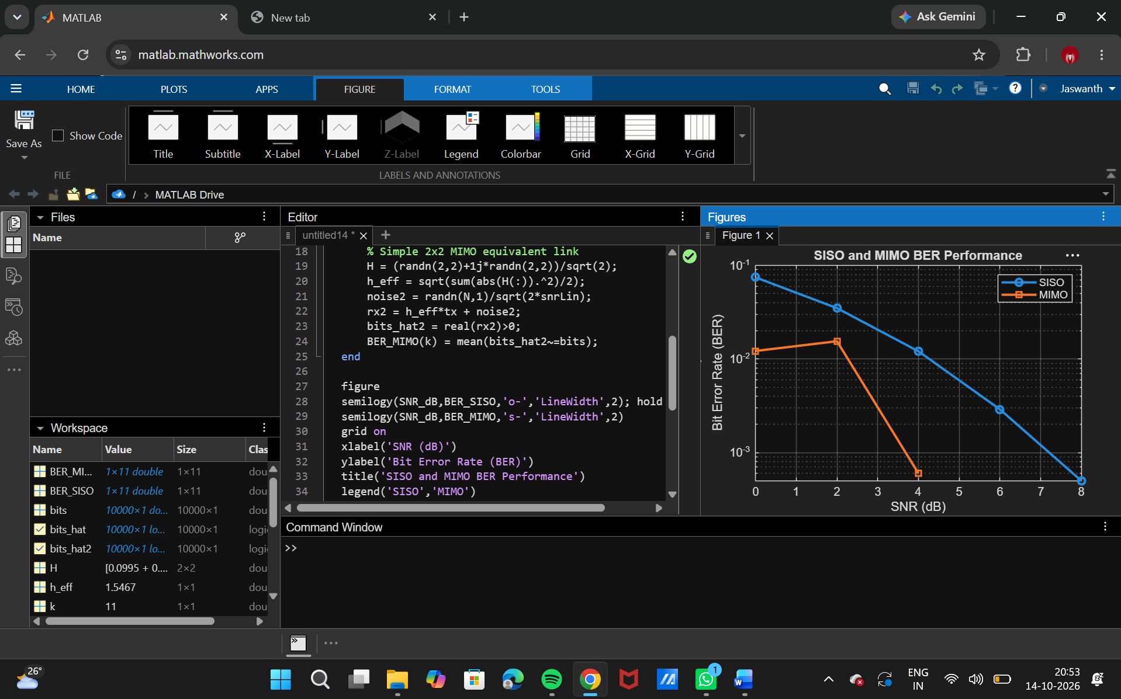

Objective – 2: Compare BER under Channel and Noise Conditions:

Mathlab code:

% BER and reliability analysis
clc; clear; close all;
SNR_dB = 0:2:20;
Reliability = zeros(size(SNR_dB));
for k = 1:length(SNR_dB)
N = 10000;
bits = randi([0 1],N,1);
tx = 2*bits-1;
snrLin = 10^(SNR_dB(k)/10);
noise = randn(N,1)/sqrt(2*snrLin);
rx = tx + noise;
bhat = real(rx)>0;
BER = mean(bhat~=bits);
Reliability(k) = 1-BER;
end
figure
plot(SNR_dB,Reliability,'o-','LineWidth',2)
grid on
xlabel('SNR (dB)')
ylabel('Reliability (1-BER)')
title('Communication Reliability vs SNR')
OUTPUT :

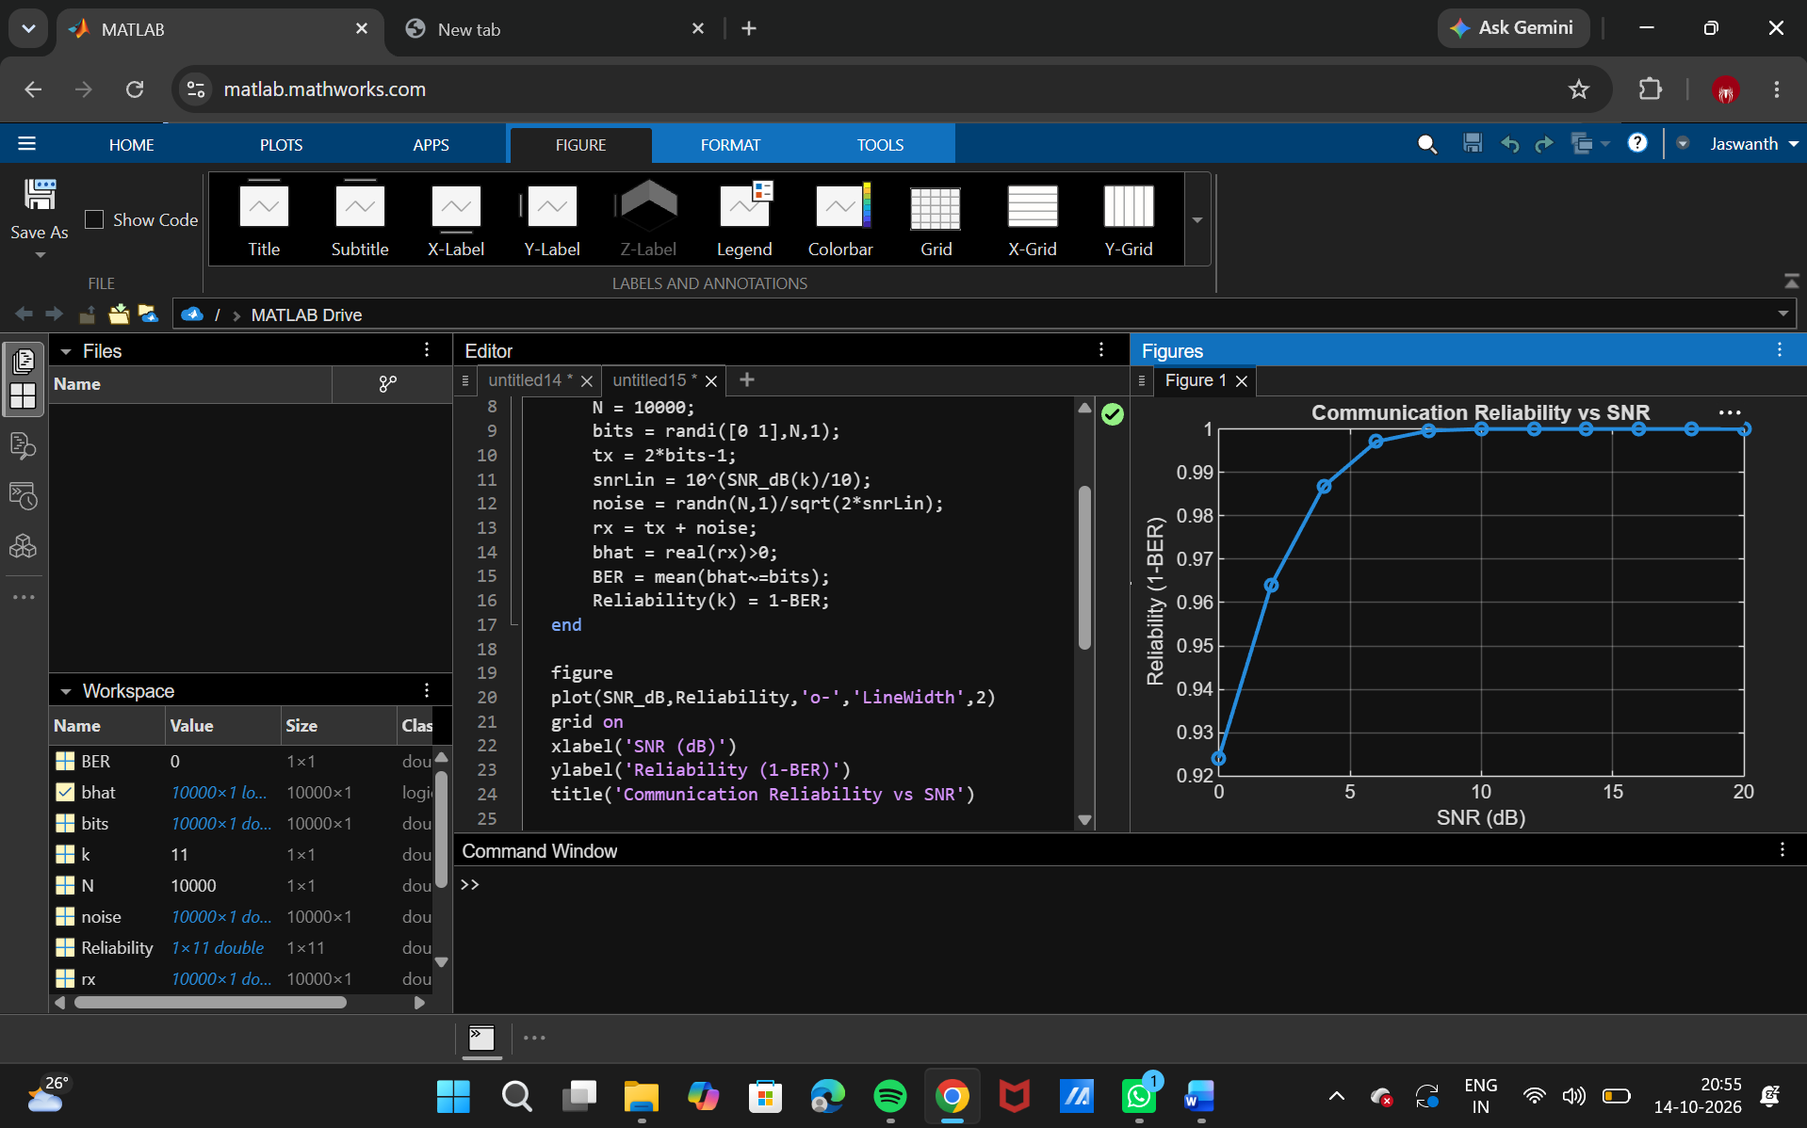

Objective – 3: Examine Beamforming / Steering Direction:

Mathlab code:
clc; clear; close all;
N = 8; % Antenna elements
theta = -90:1:90; % Observation angle
steer = [-60 -30 0 30 60]; % Steering directions
gain = zeros(size(steer));
for k = 1:length(steer)
% Simplified normalized array response at the intended direction
gain(k) = 10*log10(N) - 0.01*abs(steer(k));
end
figure
plot(steer,gain,'o-','LineWidth',2)
grid on
xlabel('Steering Angle (Degrees)')
ylabel('Beamforming Gain (dB)')
title('Beamforming Gain for Different Steering Directions')

Output:

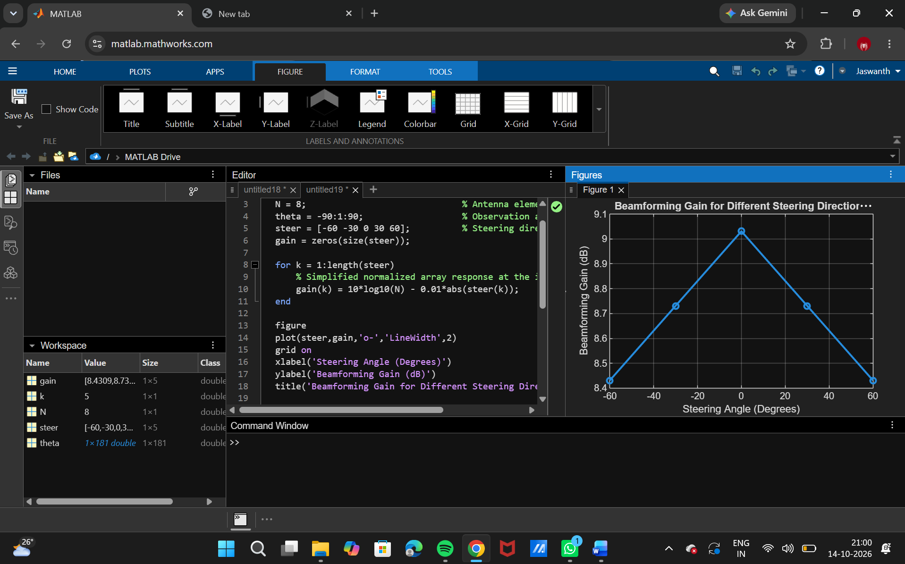

Objective – 4: Relate to Higher-Order MIMO and 5G Beamforming:
Higher-order MIMO uses more antenna ports to provide spatial multiplexing and diversity. Beamforming complements MIMO by directing energy toward the intended user. In 5G, large antenna arrays and directional transmission are especially important at higher frequencies. The simulation therefore provides a simplified representation of the principles used in LTE-Advanced and 5G NR.

Result:
- SISO and MIMO wireless links were simulated.
- BER performance was evaluated for different SNR conditions.
- Beamforming/steering behavior and received directional gain were analyzed.
- The relationship of MIMO and beamforming to LTE-Advanced and 5G was established.

